Day 1 Cancel Workrelationship

Day1 Lifecycle Events

Voyager Pending Worker Cancel Work Relationship Day 1 Lifecycle Event
Attribute | Value
Lifecycle Event Name | Voyager Pending Worker Cancel Work Relationship Day1
Type | Rule
Rule Name | Voyager Pending Worker Cancel Work Relationship Trigger Rule

Event Rule Logic
- The previous identity object must contain an active HCM link.
- The updated identity object must not contain any HCM link.
This ensures that the workflow is triggered only when an HCM account has been removed.

Additional Criteria
The lifecycle event executes only if the following conditions are met:

1. Worker Type Condition
- WorkerType must be must be NULL

2. Joiner Status
Must be one of the following:
- Pending PreHire Associate
- PreHire Associate Initiated
- PreHire Associate Completed

Flow Chart
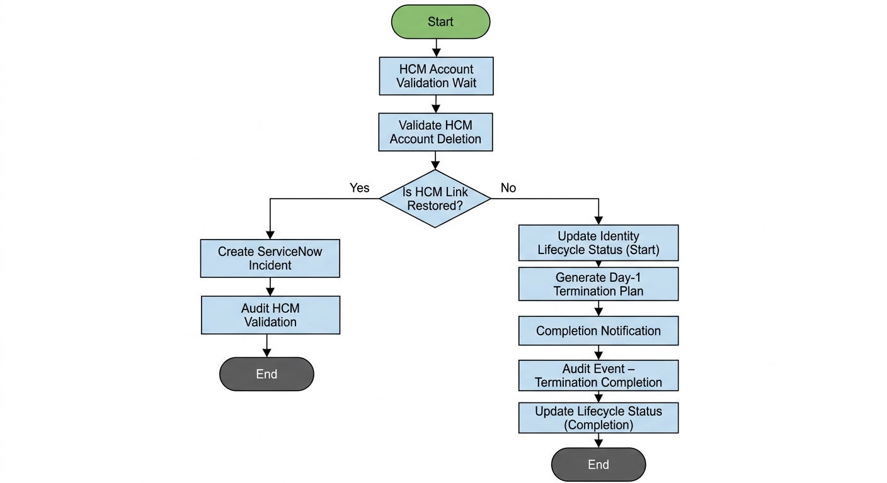

Step Summary

Step Summary Table

Step No | Step Title | Step Summary
1 | Start | Workflow is triggered when the Day-1 Cancel Workrelationship process is initiated for an identity.
2 | HCM Account Validation Wait | Workflow pauses for a defined time to confirm whether the HCM account reappears due to any feed issue before proceeding with termination.
3 | Validate HCM Account Deletion | System checks if the HCM account link is restored after the wait period. If restored, incident and audit are created and workflow stops; otherwise proceeds.
4 | Create ServiceNow Incident | Automatically creates an incident capturing details when an accidental cancel work relationship trigger is detected and HCM account is restored.
5 | Audit HCM Validation | Generates an audit event to log accidental termination initiation along with identity attributes for traceability and compliance.
6 | Retrieve Identity Data | Fetches required identity attributes such as employee details, termination date, and status for use in provisioning, audit, and notifications.
7 | Audit Event – Termination Initiation | Records the formal initiation of the Day-1 termination process with full identity attribute logging.
8 | Update Identity Lifecycle Status (Start) | Updates lifecycle attributes to indicate termination process has started and captures the current system date.
9 | Generate Day 1 Termination Provisioning Plan | Builds provisioning actions to move AD accounts to Disabled OU and deactivate application accounts except approved exceptions.
10 | Provisioning Execution | Executes the termination provisioning plan and creates an incident if errors or warnings occur during execution.
11 | Completion Notification | Sends notification to the user’s manager confirming successful execution of Day-1 termination activities.
12 | Audit Event – Termination Completion | Logs an audit event to capture successful completion of the termination process with identity details.
13 | Update Identity Lifecycle Status (Completion) | Updates lifecycle attributes to reflect completion of Day-1 termination and records completion date.
14 | End | Workflow ends after lifecycle update, audit logging, and notification activities are completed.

Workflow description

Day 1 Cancel Workrelationship Plan – Technical Workflow

1. Start
The “Voyager Cancel WorkRelation Day 1” workflow is initiated when the Day 1 Cancel Workrelationship process is triggered for an identity.

2. HCM Account Validation Wait

This step is designed to address scenarios where the user’s HCM account may have been

unintentionally removed from the feed file due to a technical issue.

The workflow pauses for a defined threshold time (currently configured as 5min but could be customized based on requirement).

If the HCM account reappears within this time frame, the termination process will not proceed.

If the HCM account does not reappear after the waiting period, the Cancel Work Relationship (Day 1) process will proceed for the user.

3. Validate HCM Account Deletion
Check if the HCM link is restored post HCM Account Wait threshold is completed.

If the HCM link is restored during the waiting period:
- A ServiceNow incident will be automatically created with all relevant details.
- An audit event will be generated in IAM capturing the incident and user information.
- The workflow will terminate without executing the Cancel Work Relationship process for the user.

If the HCM Link is still not restored after the waiting period then proceed with Retrieve Identity Data

4. Create ServiceNow Incident

- Create a ServiceNow Incident providing all the relevant details of the user and informing that an accidental Cancel Work relationship was triggered for this user but HCM account came back for the user.

5. Audit HCM Validation

An Audit Event is generated to record the accidental Cancel Workrelationship process.
- Audit Event Name: " Accidental Cancel Work Relationship “
- Audit Data: All retrieved identity attributes are captured and stored as part of the audit record.
This ensures traceability and compliance for termination-related activities.

6. Retrieve Identity Data
The workflow retrieves the following identity attributes required for the termination process:
- employeeType
- assignmentAction
- assignmentStatusTypeCode
- terminationDate
- firstname
- lastname
- employeeId
- effectiveEndDate
These attributes are used for audit logging, provisioning logic, and notification purposes.

7. Audit Event – Termination Initiation
An Audit Event is generated to record the initiation of the termination process.
- Audit Event Name: Initiated - Cancel Work Relationship Day 1
- Audit Data: All retrieved identity attributes are captured and stored as part of the audit record.
This ensures traceability and compliance for termination-related activities.

8. Update Identity Lifecycle Status (Start)
The identity lifecycle attributes are updated to indicate that the termination process has begun.
- terminationStatus: Day-1 Cancel Started
- terminationStatusDate: Current system date
This flag is used to track the progress of the termination lifecycle process.

9. Generate Day 1 Termination Provisioning Plan
A provisioning plan is generated with the following actions:

5.1 Active Directory Account Handling
All Active Directory accounts associated with the user are moved to the Disabled OU based on mappings defined in the custom configuration object:
- Configuration: Ascension-Custom-AD-DomainMapping

5.2 Application Account Deactivation
All application accounts linked to the identity are disabled, except for the following applications:
- EPM Cloud EDMCS
- EPM Cloud Planning
- EPM Cloud FCCS
- EPM Cloud ARCS
- EPM Cloud EPCM
- UKG
- Oracle HCM Cloud
- Oracle ERP Procurement Agent
These applications remain active as part of the exceptional approval from the Ascension IAM Team.

10. Provisioning Execution
The generated termination plan is executed using the Voyager LCM Provisioning Workflow.
After provisioning:
- The ProvisioningResult from the ProvisioningProject is evaluated.
- If errors or warnings are detected:
  - A ServiceNow Incident Ticket is automatically created.
  - The ticket includes:
    - Request details
    - Identity information
    - Error or warning messages returned from the provisioning process
This ensures operational visibility and prompt remediation of provisioning failures.

11. Completion Notification
Once provisioning is completed, a termination completion notification is sent to the user’s manager informing them that the Day 1 termination process has been executed.

12. Audit Event – Termination Completion
A second Audit Event is generated to record the successful completion of the termination process.
- Audit Event Name: Completion - Cancel Work Relationship Day 1
- Audit Data: All retrieved identity attributes are logged for traceability.

13. Update Identity Lifecycle Status (Completion)
The identity lifecycle attributes are updated to reflect completion of the Day 1 termination process.
- terminationStatus: Day-1 Cancel Finished
- terminationStatusDate: Current system date
This marks the successful completion of the Day 1 termination workflow.

14. End
The workflow terminates after updating the lifecycle status and completing all required audit and notification steps.

Day3 Cancel Workrelationship

Day3 Lifecycle Events

Voyager Pending Worker Cancel Work Relationship Day 3 Lifecycle Event

Attribute | Value
Lifecycle Event Name | Voyager Pending Worker Cancel Work Relationship Day 3
Type | Rule
Rule Name | Voyager PendingWorker Cancel - Day 3 Trigger Rule

Event Rule Logic
The lifecycle event is triggered when:

1. Termination Status Date Condition
- terminationStatusDate identity attribute that is updated in Day1 Cancel Workflow must be:
  - 3 or more days in Past

Additional Criteria
The lifecycle event executes only if the following conditions are met:

1. Termination Status Validation
- Identity attribute terminationStatus must be Day-1 Cancel Finished
(This ensures Day-3 workflow does not run multiple times)

Day3 Flow Chart
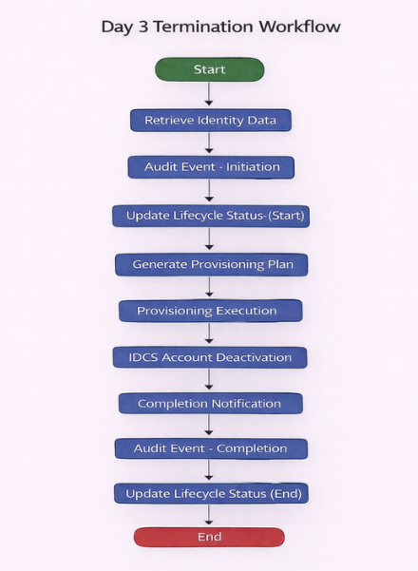

Day 3 Step Summary

Step Summary Table
Step No. | Step Title | Step Description
1 | Start | Initiates the Day 3 workflow as a follow-up to the successful completion of Day 1 termination activities.
2 | Retrieve Identity Data | Retrieve core attributes (e.g., employeeId, assignmentStatus, terminationDate) for use in provisioning and audit logs.
3 | Audit Event – Initiation | Records a formal "Initiated" audit entry in the system to ensure traceability of the Day 3 offboarding process.
4 | Update Lifecycle Status (Start) | Updates the identity's terminationStatus to "Day-3 Cancel Started" and stamps the current system date.
5 | Generate Provisioning Plan | Compiles a plan to retrieve EPM email IDs, strip all application entitlements, and remove roles and disconnected accounts.
6 | Provisioning Execution | Executes the plan via the Voyager LCM if errors occur, a ServiceNow incident ticket is automatically generated for manual review.
7 | IDCS Account Deactivation | Triggers a direct API call to Oracle IDCS to disable the user account, which subsequently deactivates linked EPM accounts.
8 | Completion Notification | Dispatches a final status email to the user’s manager confirming completion and detailing any provisioning warnings.
9 | Audit Event – Completion | Logs a "Completion" audit entry containing the final identity state to signify the end of the technical workflow.
10 | Update Lifecycle Status (End) | Transitions the identity's terminationStatus to "Day-3 Cancel Finished" to close the lifecycle event.
11 | End | Terminates the workflow instance after all provisioning, deactivation, and logging tasks are confirmed.

Day3 Workflow Description

Day 3 Cancel Work Relationship Plan – Technical Workflow

1. Start
The “Voyager Cancel WorkRelation Day 3” workflow is initiated as part of the termination lifecycle process following the completion of the Day 1 termination activities.

2. Retrieve Identity Data
The workflow retrieves the following identity attributes required for the termination process:
- employeeType
- assignmentAction
- assignmentStatusTypeCode
- terminationDate
- firstname
- lastname
- employeeId
- effectiveEndDate
These attributes are used for audit logging, provisioning decisions, and notification purposes.

3. Audit Event – Termination Initiation
An Audit Event is generated to capture the initiation of the Day 3 termination process.
- Audit Event Name: Initiated - Cancel Work Relationship Day 3
- Audit Data: All retrieved identity attributes are recorded as part of the audit event.
This ensures traceability and provides a record of when the Day 3 termination process was initiated.

4. Update Identity Lifecycle Status (Start)
The identity lifecycle status attributes are updated to indicate that the Day 3 termination process has started.
- terminationStatus: Day-3 Cancel Started
- terminationStatusDate: Current system date
This status helps track the progress of the termination lifecycle.

5. Generate Day 3 Termination Provisioning Plan

5.1 Retrieve Email ID from EPM Accounts
The workflow iterates through the user's EPM application accounts to retrieve the associated email address.
- The email ID is extracted from the first available EPM account.
- Once retrieved, the loop terminates.
- The email ID is stored in a workflow variable.
This email address is later used for invoking the IDCS Disable API.

5.2 Remove Application Entitlements
A provisioning plan is created to remove all entitlements associated with the user across all connected application accounts.

5.3 Remove Disconnected Accounts
All disconnected application accounts associated with the user (managed through the Delimited File Connector) are deleted as part of the provisioning plan.

5.4 Remove IdentityIQ Roles
All roles assigned to the user within IdentityIQ are removed, including:
- Assigned Roles
- Detected Roles
This ensures that the identity no longer retains any role-based access within IdentityIQ.

6. Provisioning Execution
The generated provisioning plan is executed using the Voyager LCM Provisioning Workflow.
After provisioning:
- The ProvisioningResult from the ProvisioningProject is evaluated.
- If any errors or warnings are detected:
  - A ServiceNow Incident Ticket is created automatically.
  - The ticket includes the request details along with the provisioning error information.

7. IDCS Account Deactivation
An API request is sent directly to IDCS (Oracle Identity Cloud Service) to disable the user account.
Disabling the IDCS account results in:
- Automatic deactivation of all EPM application accounts associated with the user.
- During the next account aggregation, the corresponding EPM account links will be removed from IdentityIQ.

8. Completion Notification
Upon completion of the process, a termination completion notification is sent to the user’s manager.
The notification includes:
- Confirmation of Day 3 termination completion
- Any errors or warnings identified in the provisioning process, if applicable

9. Audit Event – Termination Completion
An Audit Event is created to record the successful completion of the Day 3 termination process.
- Audit Event Name: Completion - Cancel Work Relationship Day 3
- Audit Data: All retrieved identity attributes are recorded.

10. Update Identity Lifecycle Status (Completion)
The identity lifecycle attributes are updated to reflect completion of the Day 3 termination process.
- terminationStatus: Day-3 Cancel Finished
- terminationStatusDate: Current system date

11. End
The workflow terminates after completing provisioning, IDCS deactivation, audit logging, and notification activities.

Day 61 Cancel Workrelationship

Day 61 Lifecycle Events

Voyager Pending Worker Cancel Work Relationship Day 61 Lifecycle Event

Attribute | Value
Lifecycle Event Name | Voyager Pending Worker Cancel Work Relationship Day 61
Type | Rule
Rule Name | Voyager PendingWorker Cancel - Day 61 Trigger Rule

Event Rule Logic
The lifecycle event is triggered when:

1. Termination Status Date Condition
- terminationStatusDate identity attribute that is updated in Day3 Cancel Workflow Relationship Workflow must be:
  - 61 or more days in Past

Additional Criteria
The lifecycle event executes only if the following conditions are met:

1. Termination Status Validation
- Identity attribute terminationStatus must be Day-3 Cancel Finished
(This ensures Day-61 workflow does not run multiple times)

Day61 Flow Chart
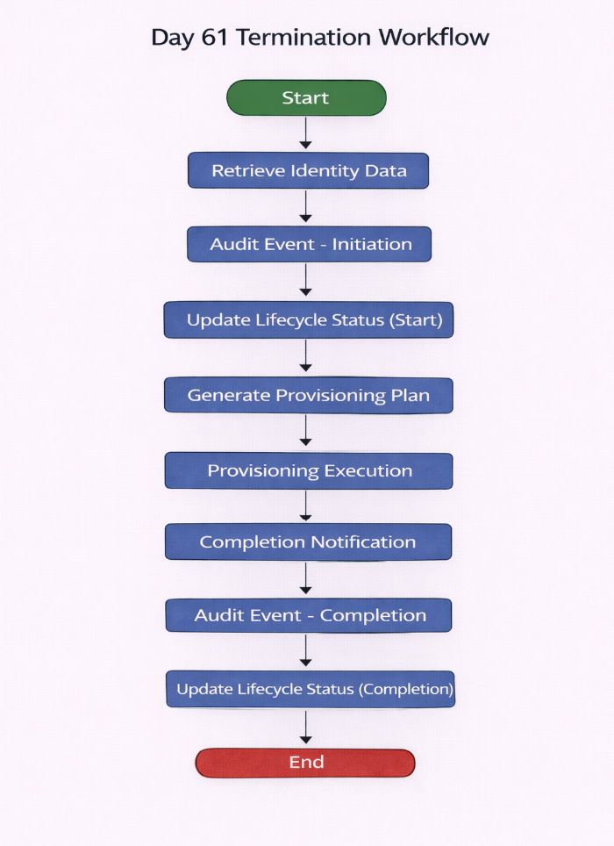

Day61 Step Summary

Step Summary Table
Step No. | Step Title | Step Description
1 | Start | Initiates the final phase of the termination lifecycle focused on long-term account cleanup.
2 | Retrieve Identity Data | Fetches required attributes (e.g., employeeType, terminationDate) for auditing and provisioning logic.
3 | Audit Event – Initiation | Records a formal "Initiated" audit entry to ensure traceability for compliance and final offboarding.
4 | Update Lifecycle Status (Start) | Sets the terminationStatus to "Day-61 Termination Started" and records the current system date.
5 | Generate Provisioning Plan | Creates a plan to delete application accounts while excluding retained systems like EPM, Oracle, UKG, and specific AD domains.
6 | Provisioning Execution | Executes the cleanup via Voyager LCM and automatically generates a ServiceNow incident if errors are detected.
7 | Completion Notification | Sends a final confirmation to the manager, including a summary of the process and any provisioning warnings.
8 | Audit Event – Completion | Logs a final "Completion" audit event capturing the identity’s state at the end of the 61-day cycle.
9 | Update Lifecycle Status (Completion) | Transitions the terminationStatus to "Day-61 Termination Finished" to signify the close of the lifecycle.
10 | End | Formally concludes the technical workflow after all deletion and logging tasks are finalized.

Day61 Workflow Summary

Day 61 Cancel Workrelationship Plan – Technical Workflow

1. Start
The “Voyager Cancel WorkRelation Day 61” workflow is initiated as part of the final phase of the termination lifecycle process. This stage focuses on long-term account cleanup and removal of remaining application accounts.

2. Retrieve Identity Data
The workflow retrieves the following identity attributes required for processing, auditing, and notification purposes:
- employeeType
- assignmentAction
- assignmentStatusTypeCode
- terminationDate
- firstname
- lastname
- employeeId
- effectiveEndDate
These attributes are used for audit logging, provisioning actions, and reporting.

3. Audit Event – Termination Initiation
An Audit Event is generated to record the initiation of the Day 61 termination process.
- Audit Event Name: Initiated - Cancel Work Relationship Day 61
- Audit Data: All retrieved identity attributes are captured as part of the audit event.
This provides traceability for compliance and auditing purposes.

4. Update Identity Lifecycle Status (Start)
The identity lifecycle attributes are updated to reflect the start of the Day 61 termination process.
- terminationStatus: Day-61 Cancel Started
- terminationStatusDate: Current system date
This lifecycle flag indicates that the final termination phase has begun.

5. Generate Day 61 Termination Provisioning Plan
A provisioning plan is generated to delete all application accounts associated with the user except for a predefined list of retained systems.

5.1 Application Account Deletion
All application accounts linked to the user are deleted as part of the termination cleanup process.

5.2 Excluded Applications
The following applications are excluded from deletion and remain retained:
EPM Applications
- EPM Cloud EDMCS
- EPM Cloud Planning
- EPM Cloud FCCS
- EPM Cloud ARCS
- EPM Cloud EPCM
Oracle Applications
- Oracle ERP Procurement Agent
- Oracle HCM Cloud
HR and Workforce Systems
- UKG
Active Directory Domains
- AD-DS
- AD-ASC
- AD-ACMHO
- AD-AHMFM
- AD-AHSCN
- AD-KSWIC
- AD-MIROC
- AD-OKTUL
- AD-WIAPP
- AD-WIGLE
- AD-Archive
- AD-AMITA
These exclusions follow the organization's data retention and system access policies.

6. Provisioning Execution
The generated termination plan is executed using the Voyager LCM Provisioning Workflow.
Post-provisioning validation is performed as follows:
- The ProvisioningResult from the ProvisioningProject is reviewed.
- If errors or warnings are detected:
  - A ServiceNow Incident Ticket is created automatically.
  - The ticket contains:
    - Identity and request details
    - Application provisioning errors
    - Relevant diagnostic information
This ensures operational visibility and remediation of any provisioning failures.

7. Completion Notification
After the completion of the provisioning process, a termination completion notification is sent to the user’s manager.
The notification includes:
- Confirmation of the Day 61 termination process completion
- Any errors or warnings detected during provisioning

8. Audit Event – Termination Completion
An Audit Event is generated to record the successful completion of the Day 61 termination process.
- Audit Event Name: Completion - Cancel Work Relationship Day 61
- Audit Data: All retrieved identity attributes are logged.

9. Update Identity Lifecycle Status (Completion)
The identity lifecycle attributes are updated to mark the completion of the Day 61 termination workflow.
- terminationStatus: Day-61 Cancel Finished
- terminationStatusDate: Current system date

10. End
The workflow concludes after completing provisioning actions, audit logging, and notification activities.

